7/24/2020

**Introduction to Database**

Assignment 3 Part B.

Shankar Sigdel

ID: 301110925

Centennial College

Prof. Vijayalakshmi Tiruchengode Angamuthu

1. Create a list that displays the title of each book and the name and phone number of the contact at the publisher’s office for reordering each book.

a) SELECT b.title, p.contact, p.phone FROM books b, publisher p WHERE b.pubid = p.pubid;

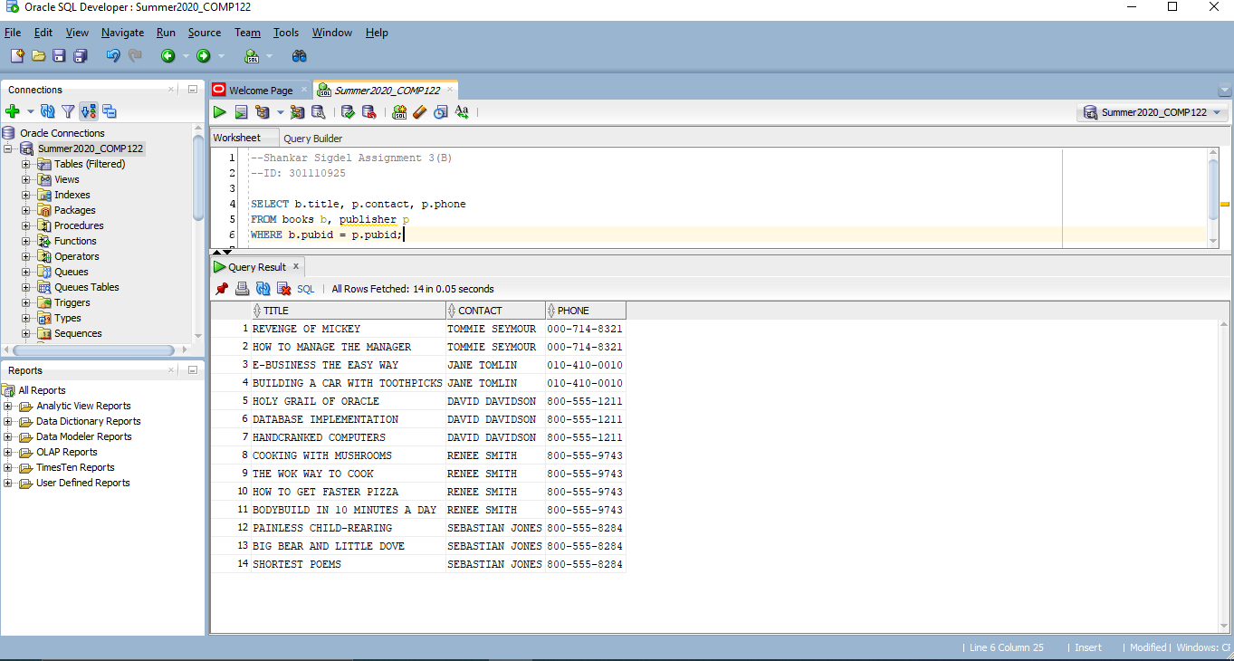

b) SELECT b.title, p.contact, p.phone FROM books b JOIN publisher p USING (pubid);

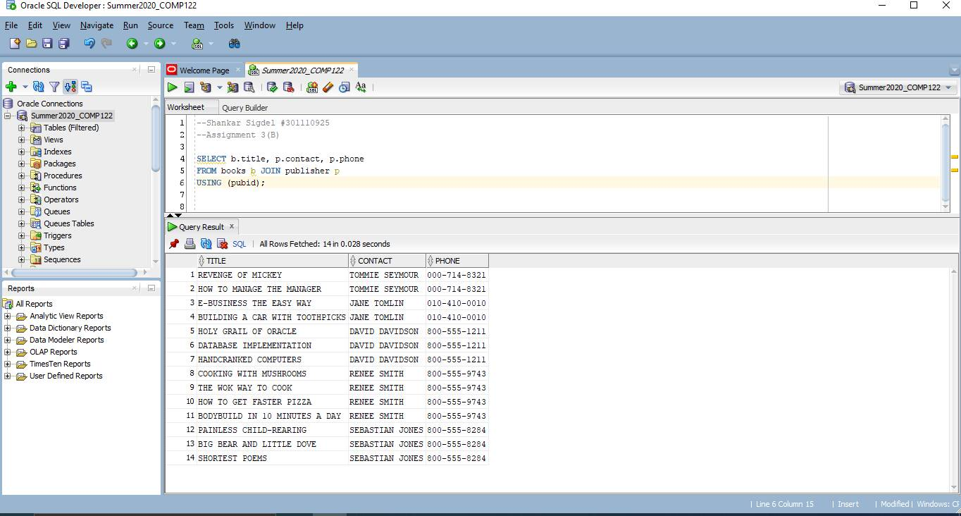

1. Determine which orders haven’t yet shipped and the name of the customer who placed the order. Sort the results by date on which the order was placed.

a) SELECT c.firstname, c.lastname, o.order# FROM customers c, orders o WHERE c.customer# = o.customer# AND o.shipdate IS NULL ORDER BY o.orderdate;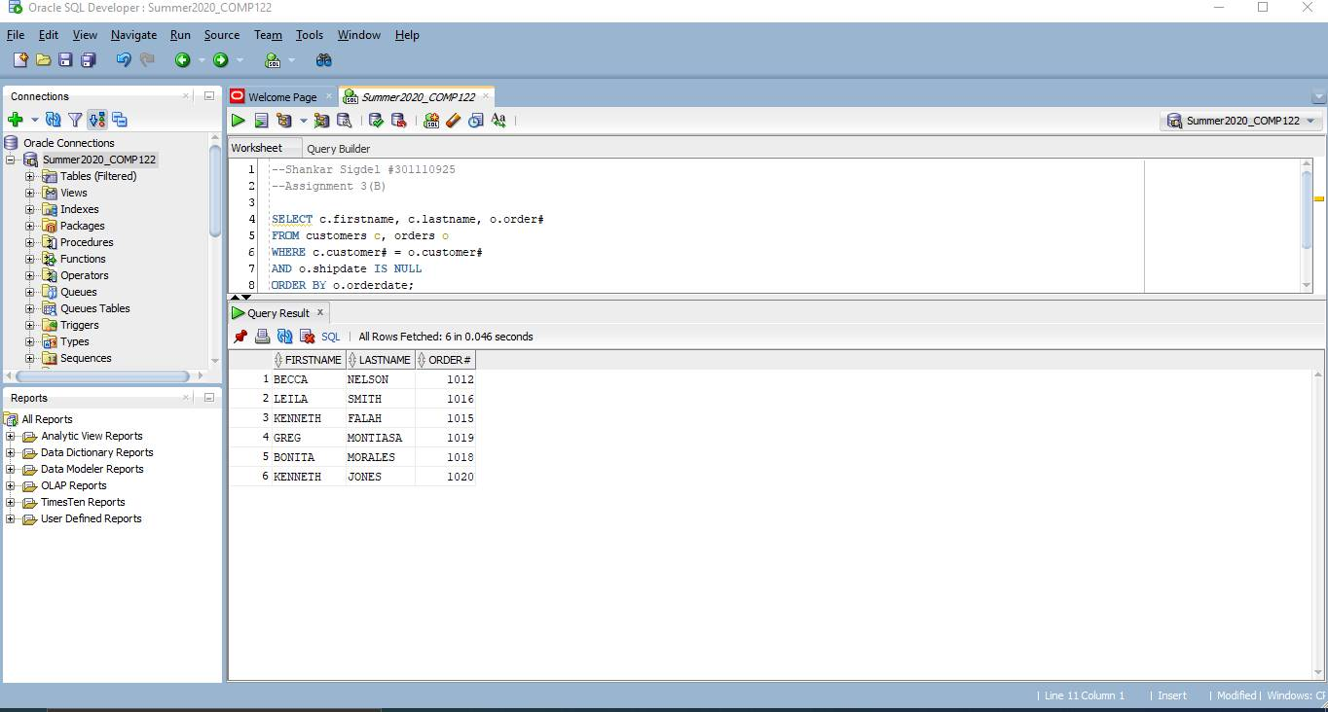

b) SELECT c.firstname, c.lastname, o.order# FROM customers c JOIN orders o USING (customer#)  
WHERE o.shipdate IS NULL ORDER BY o.orderdate;

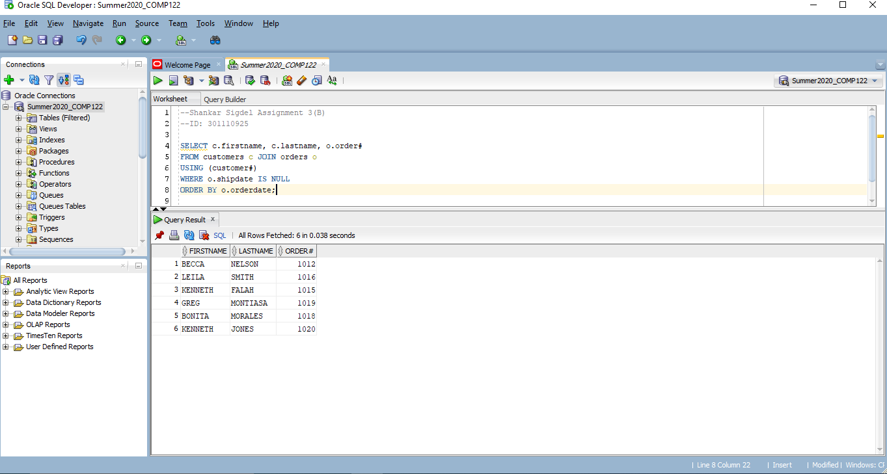

1. Produce a list of all customers who live in the state of Florida and have ordered the books about computers.

a) SELECT DISTINCT c.lastname, c.customer# FROM books b, orders o, orderitems i, customers c WHERE c.customer# = o.customer# AND o.order# = i.order# AND i.isbn = b.isbn AND c.state = 'FL' AND b.category = 'COMPUTER';

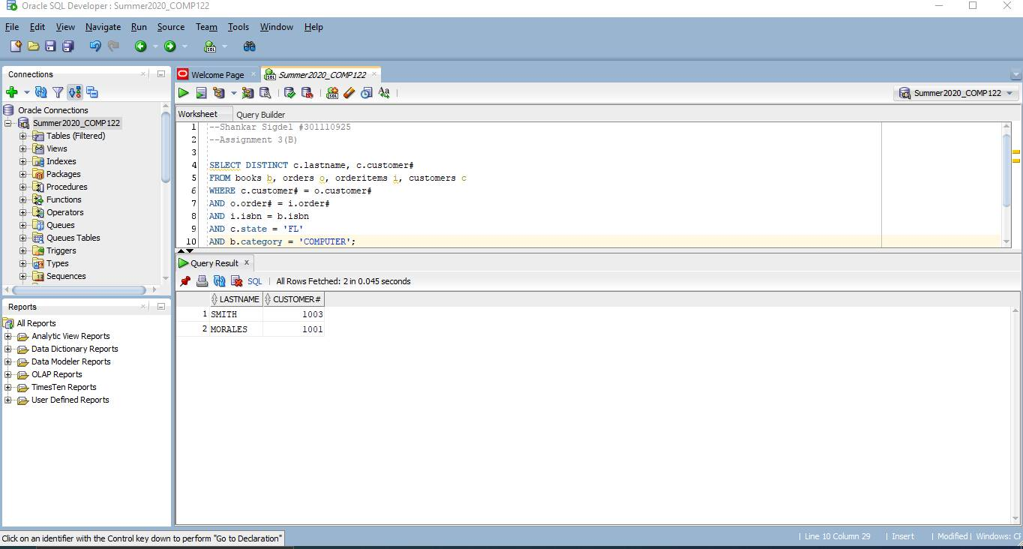

b) SELECT DISTINCT c.lastname, customer# FROM books b JOIN orderitems USING (isbn) JOIN orders USING (order#) JOIN customers c USING (customer#) WHERE c.state = 'FL' AND b.category = 'COMPUTER';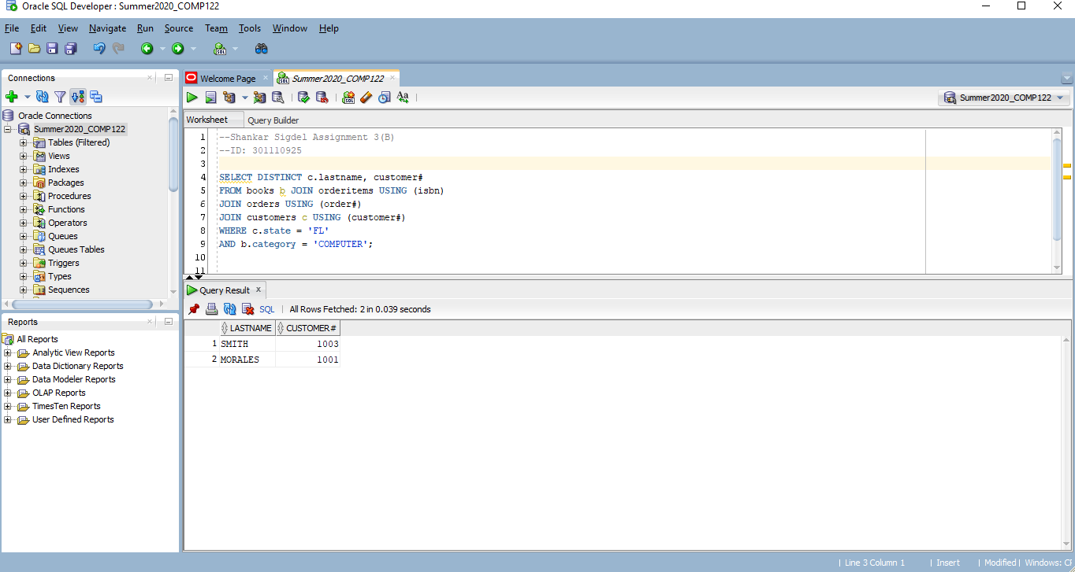

1. Determine which books customer Jake Lucas has purchased. Perform the search using the customer name, not the customer number. If he has purchased multiple copies of the same book, unduplicate the result.

a) SELECT DISTINCT b.title FROM customers c, orders o, orderitems i, books b  
WHERE c.customer# = o.customer# AND o.order# = i.order# AND i.isbn = b.isbn  
AND c.firstname = 'JAKE' AND c.lastname = 'LUCAS';

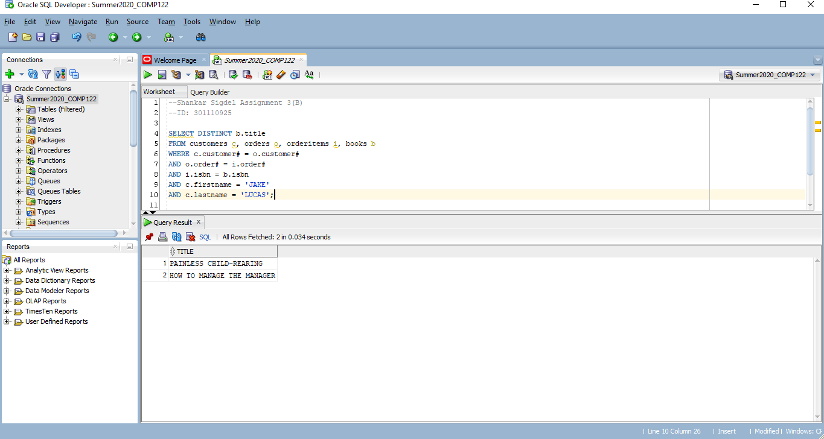

b) SELECT DISTINCT b.title FROM customers c JOIN orders USING (customer#) JOIN orderitems USING (order#) JOIN books b USING (isbn) WHERE c.firstname = 'JAKE'  
AND c.lastname = 'LUCAS';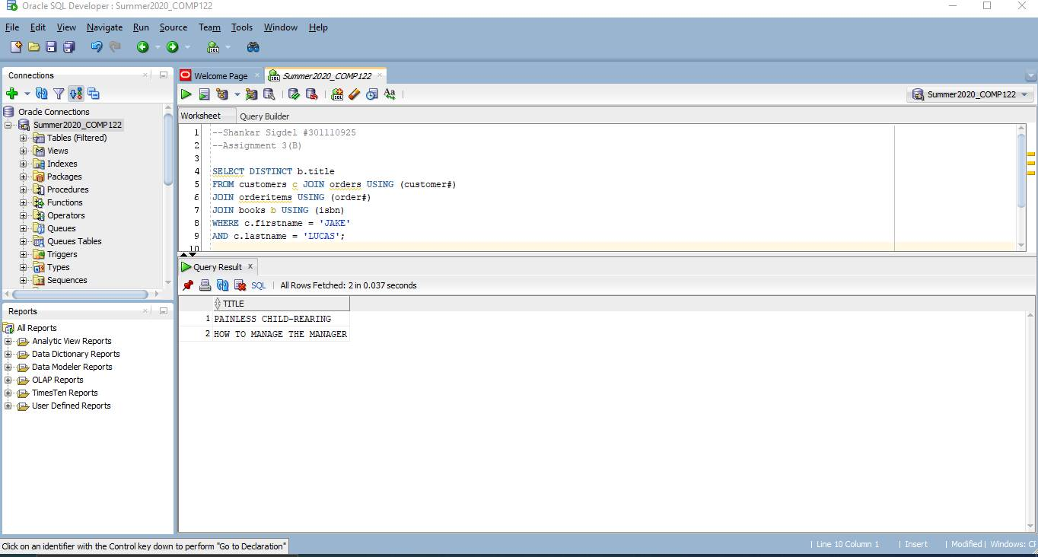

1. Determine the profit of each book sold to Jake Lucas, using the actual price the customer paid (not the book’s regular retail price). Sort the results by order date. If more than one book was ordered, sort the results by profit amount in descending order. Perform the search using the customer name, not the customer number.

a) SELECT b.title, i.paideach-cost FROM customers c, orders o, orderitems i, books b  
WHERE c.customer# = o.customer# AND o.order# = i.order# AND i.isbn = b.isbn  
AND c.firstname = 'JAKE' AND c.lastname = 'LUCAS' ORDER BY o.orderdate, i.paideach-b.cost DESC;

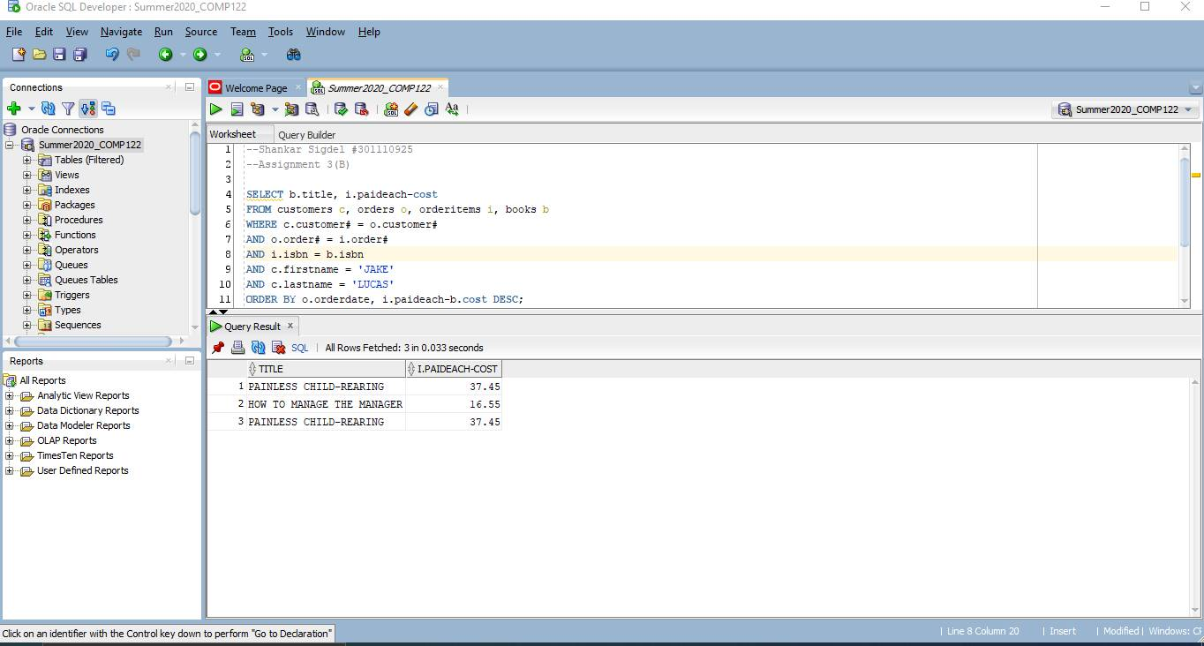

b) SELECT b.title, i.paideach-b.cost FROM customers c JOIN orders o USING (customer#) JOIN orderitems i USING (order#) JOIN books b USING (isbn) WHERE c.firstname = 'JAKE' AND c.lastname = 'LUCAS' ORDER BY o.orderdate, i.paideach-b.cost DESC;

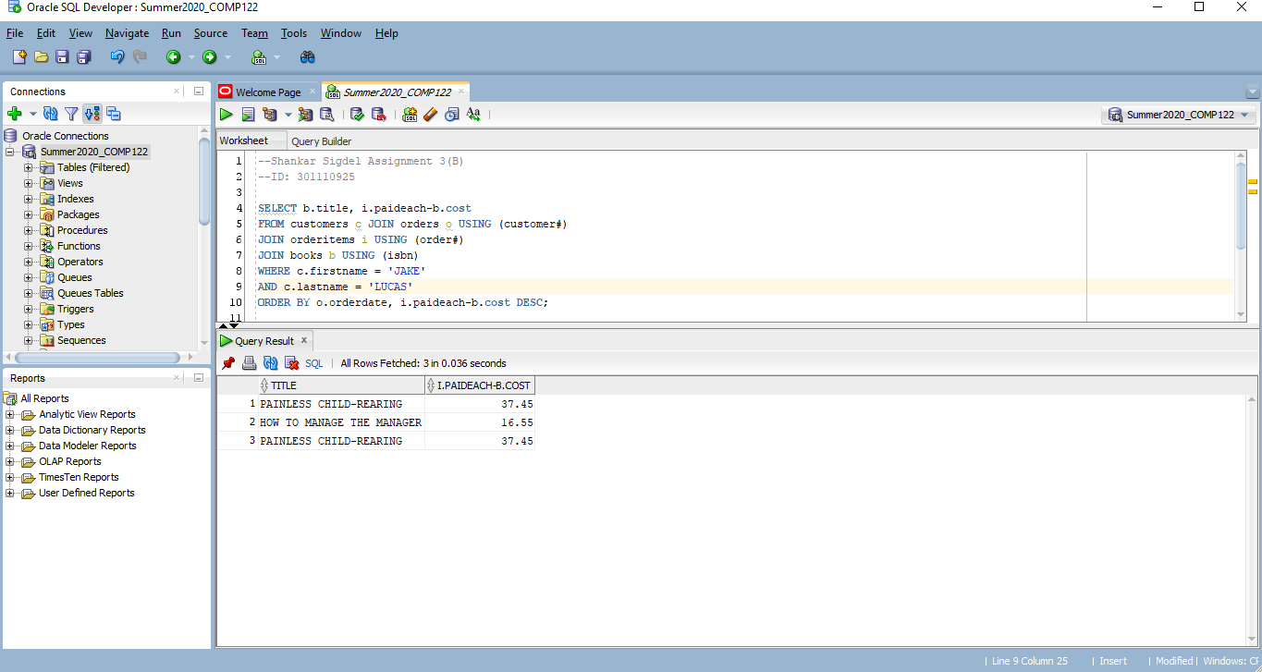

1. Which books were written by an author with the last name Adams? Perform the search using the author name.

a) SELECT b.title FROM books b, bookauthor ba, author a WHERE b.isbn = ba.isbn AND ba.authorid = a.authorid AND a.lname = 'ADAMS';

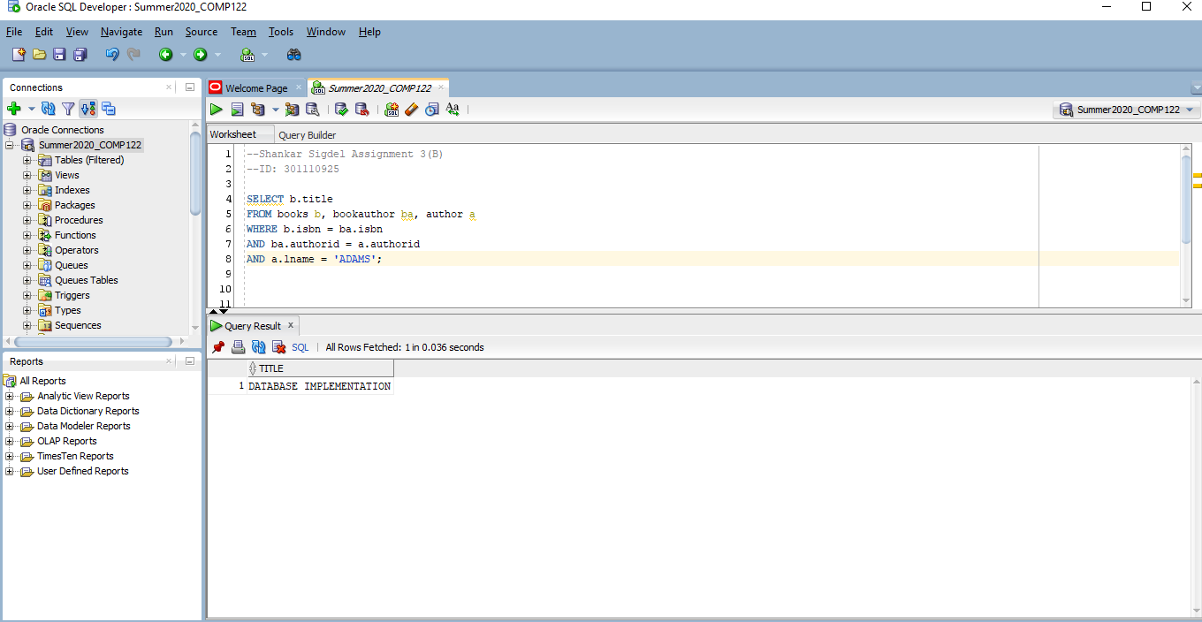

b)SELECT b.title FROM books b JOIN bookauthor USING (isbn) JOIN author a USING (authorid) WHERE a.lname = 'ADAMS';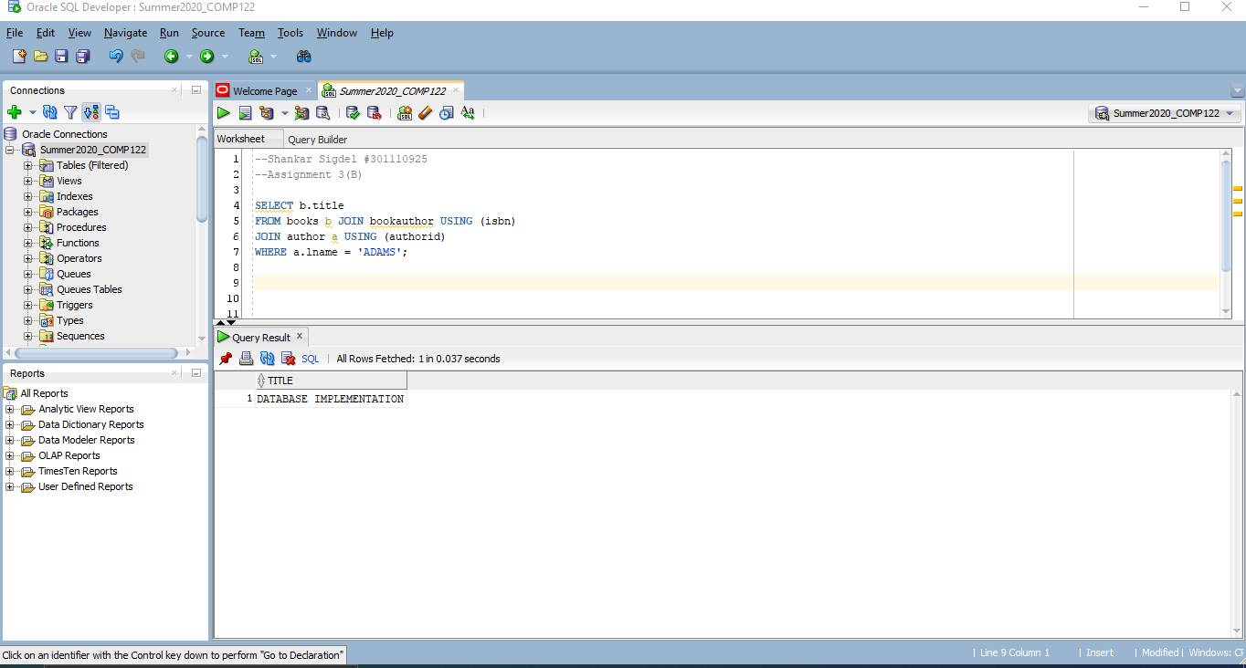

1. What gift will a customer who orders the book Shortest poems receive? Use the actual book retail value to determine the gift.

a)SELECT p.gift FROM books b, promotion p WHERE b.retail BETWEEN p.minretail AND p.maxretail AND b.title = 'SHORTEST POEMS';

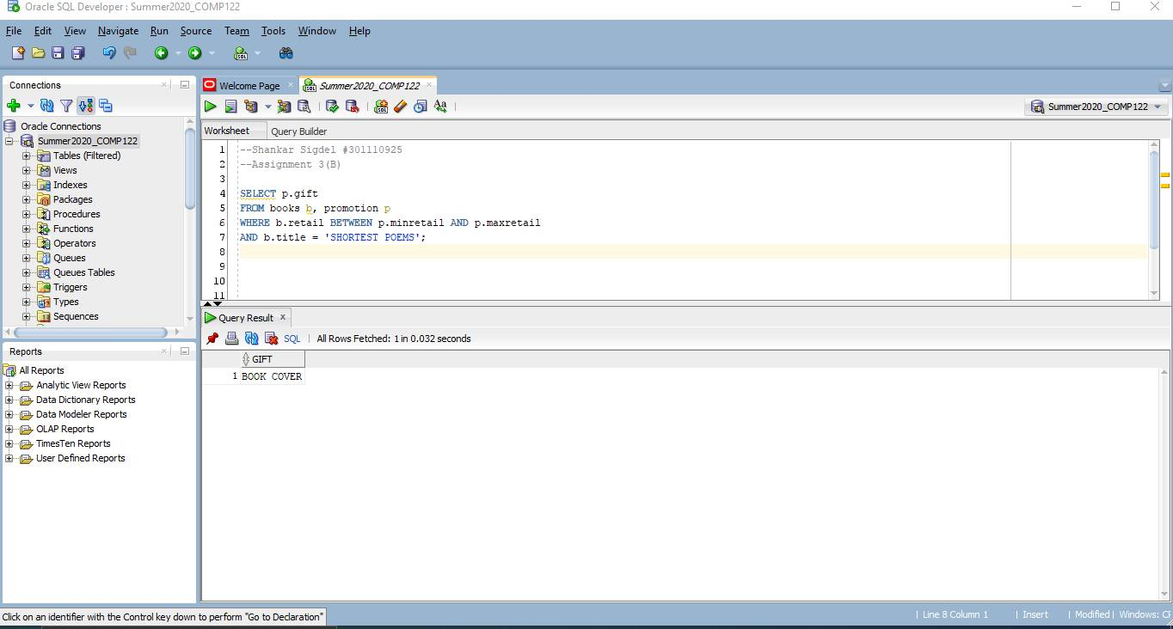  
  
b) SELECT p.gift FROM books b JOIN promotion p ON b.retail BETWEEN p.minretail AND p.maxretail WHERE b.title = 'SHORTEST POEMS';

